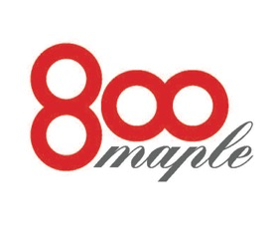
800 MAPLE BUFFET BRUNCH/LUNCHEON MENU
BAR:
CHARGE BASED ON CONSUMPTION
OPEN BAR AVAILABLE
LIMITED BAR AVAILABLE

BUFFET LUNCHEON:
$19.95/HEAD
FRUIT SALAD
GIAMBOTA (EGGS, SAUSAGE, POTATO, ONION, PEPPERS)
CHICKEN CUTLETS
MIXED GREEN SALAD
RIGATONI W/ FENNEL AND TOMATO SAUCE
FRESH BREAD
HOMEMADE BAKED GOODS

